Deploy on netlify
1)First create build folder using
npm run build
2)Run
netlify deploy
3)Then it will ask you questions
first ans is Y
second ans is ./build

deploy using git repo
1) first create __redirects file in public folder with following contents
/react http://www.blog.sscrypts.com/ 200
/react/* http://www.blog.sscrypts.com/ 200

2) Create a repo and push project in that git repo

3) login to yout netlify account and then deploy using git option select

4) we will add subdomain to blog so
first goto custom domain in netlify and verify domain
www.blog.sscrypts.com

after it will redirect and then click on check dns configuration

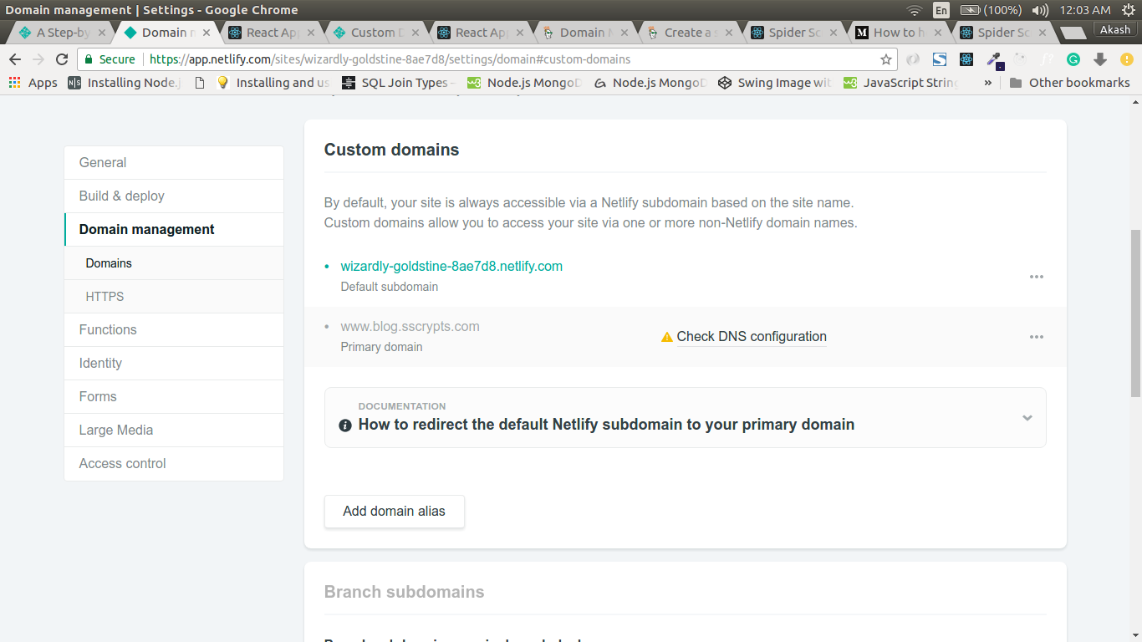

It will then give below screen

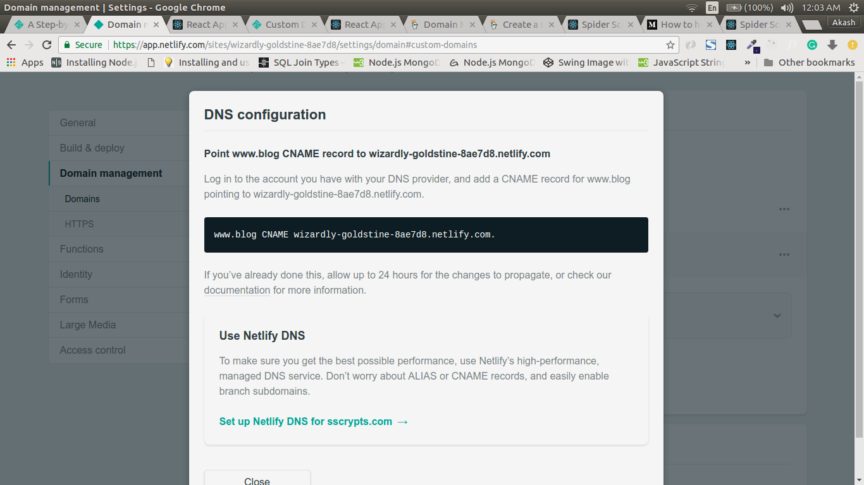

now goto godaddy and add CNAME from above info
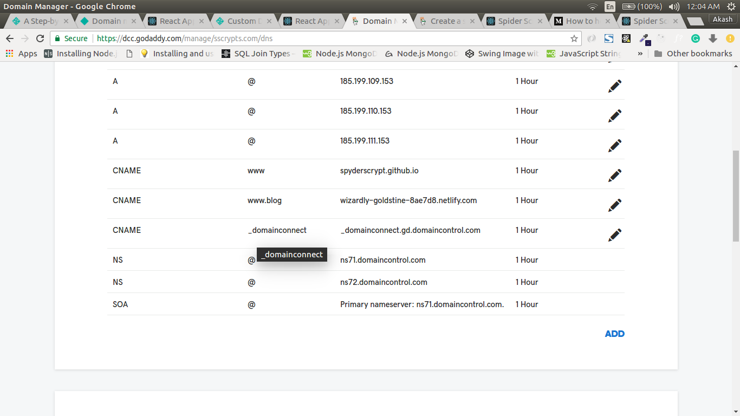

now check your app

Normal Domain ( not subdomain ) screenshots
